

Northallerton Mowbray one hour 5 – the 10 Snickets

This one hour walk is based on the '8 Snickets walk' shown in the Northallerton Strollers Walk Pack, but extended slightly for our faster walkers.
For maps, see the Walk 4 Life site :
http://www.walk4life.info/walk/northallerton-mowbray-one-hour-5-the-10-snickets
Or the GetAMap site, which also shows the original 8 snicket walk:
http://www.getamap.ordnancesurveyleisure.co.uk/?key=YHZtFjbTTLCL_ZfIKOmpuA2

Starting from Mowbray Surgery in Malpas Road, cross the road and walk down Beaconsfield Street. In the bottom left corner, go through the fence and bear left to South Parade. Cross the road at the crossing and turn left and then right down the narrow snicket to come out on Thirsk Road.
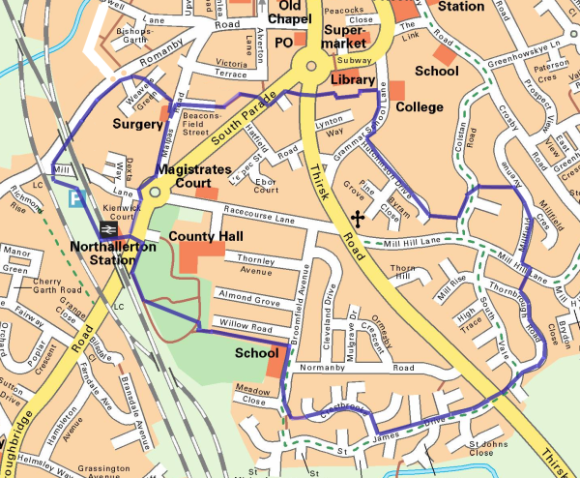
© Hambleton Strollers 2012
Cross with great care, and go under the arch, following round to come out opposite the college in Grammar School Lane. Turn right and round the bend, cross over to Hutchinson Drive, and at the end go through snicket 4 into Colstan Road.
Turn left and cross the road to find another snicket – be careful of the step halfway down here – and turn right onto Millfield Avenue.
(Note – if you are doing this walk the other way round, the end of the snicket in Millfield Avenue is very easy to miss. Look out for the lamppost which appears to be in somebody’s garden – it’s really on the snicket.)
At the end of Millfield Avenue, turn left and cross Mill Hill Lane to find snicket number 6 bedside the postbox. Follow Thornbrough Road round to the gap in the hedge and cross back over Thirsk Road with care – there is a traffic island which you should use if the road is busy.
Down St James and Crestbrooke to ‘the Fort’ and snicket number 7 out to Broomfield Avenue, then past the school turn left onto snicket number 8, which takes you along to the County Hall carpark and through the gates in and out of the playing field and beside the railway to emerge onto Boroughbridge Road. Walk up the hill and cross at the pelican crossing to arrive beside the Station.
Here you have a choice. The standard 8 snicket walk returns from here past the Station Hotel and across Mill Lane to Malpass Road, but the slightly longer 10 snickets has a more challenging route – through the station.
Follow tthe signs for Northbound Trains under the track, and up the slope onto the platform, then veer left into the car park and either down the steps to the lower car park, or along to the end and follow the road down. Cross Mill Lane and under the railway to follow Romanby Road as far as Weavers Green. Here we have our last two snickets, firstly across the grass (ok, it’s not really a snicket) and then through to Malpass Road to turn right and return to the Surgery.
Shortcuts
If you want a shorter walk, you can either come back over Mill Hill (from Millfield Avenue or Colstan Road), or for a 30 minute walk, follow round Grammar School Lane to Thirsk Road. In all these cases, return along Racecourse Lane and Malpas Road, taking great care crossing South Parade.

We hope you enjoy your walk and have no problems following these directions. If you do encounter any problems (with the walk or the directions), please let us know and we will correct them, and don't forget to add your comments on the walk 4 life site.

John Brookes
Northallerton Striders

February 2012

