
3 Heart Walks
Walk 1 - Viewly Hill

This walk takes about 75 minutes as described, so it’s really a 2½ heart walk, but you can easily extend it on the way back through Romanby. There are also a couple of shortcuts, and an optional extension to see the river Wiske. A variation on the walk is included in the Strollers walk pack, but this is slightly longer.

This walk includes fields and kissing gates (the stiles were replaced with gates in 2010 by NYCC), so there will be mud in wet weather and possibly nettles on the shortcut beside the football field. There is also a bridge with steps up and down which can be slippery.

See the map on GetAMap
http://www.getamap.ordnancesurveyleisure.co.uk/?key=CBUkZAy9yshB2xA59RPjCQ2

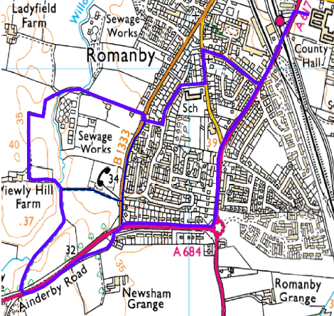
Starting from County Hall, head out of the main gate, under the bridge and across the crossing. Walk along Boroughbridge Road past the doctor‘s surgery, and out to the roundabout. Turn right down Lees Lane and walk down the hill. Before the junction with
Ainderby Road, cross
Lees Lane and walk round the old loop which is now used as a lay-by.
If you want a much shorter version of this walk, drive to this lay-by and leave your car here. This will give you all the countryside part of the walk with the minimum of road walking.
© Crown copyright. All rights reserved. 100017946 2008

From the lay-by, take the footpath alongside the main road. This can be hard to spot in summer, as it is a gap in the bank close to the hedge, and it gets quite overgrown but it is tarmacced and soon climbs up to the level of the verge. Follow this path
just over the brow of the hill, and look out across the road for a kissing gate and signpost. Take care crossing this road - cross at the top of the hill to get best visibility and watch out for cars travelling at high speeds.

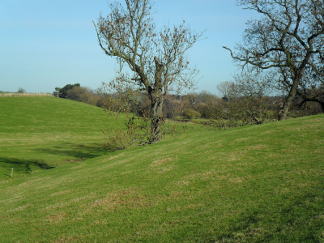
Once through the gate, head to your right diagonally across the field. There is no obvious path, and it‘s not clear if you should go over the hill or down round the stream. Most people choose to drop down the steep grassy bank and follow the path round by the stream, but this is rough and can be muddy. Staying up is drier, but the descent is quite steep at the other side unless you walk well round.

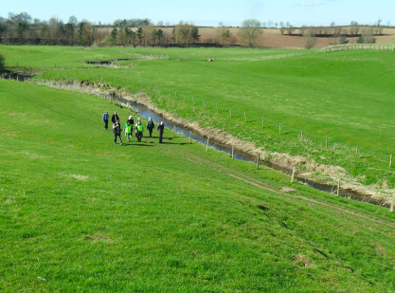
In hot weather you may be tempted by the ford over the stream. The water may look clear and inviting, but remember you are just downstream of the sewage works! Nowadays most of the waste is piped, and you can see the manholes as you walk round, but during heavy rain the excess may go straight into this stream, so be warned.

Following the stream on round to the corner of the field, we find a gated footbridge. Cross this and turn left, round the edge of the field – or just follow the cow path straight over the top. Go through the kissing gate out onto the track and turn right to follow the track as it winds through the fields. As you approach the stream, you can see the sewage works and the overflow - hopefully dry.

As you cross the bridge, pause for a minute and enjoy the peace. Despite the sewage works, there are fish in the stream and birds in the trees, and apart from the occasional vehicle going into the works, it is quiet. Once over the bridge, we have to deal with the traffic again, so make the most of this moment.

This stream is Willow Beck and it joins the Wiske just downstream of where we first saw it. Upstream it is known by other names – as it flows beside the leisure centre it is North Beck while further on it’s called Brompton Beck.

Across the bridge, go straight ahead, along the road. This is the main access to the works, and is very narrow so you can expect to have to stand aside while something goes past. For some reason it‘s called Wooden Hill Lane - neither wooded nor hilly, at least it is a lane! At the end you come out onto Ainderby Road, and have plenty of choice about the rest of the walk. If you went for the short version, turn right to get back to your car, or turn left to head into Northallerton centre. To get back to County Hall, the nicest (quietest) route is to bear right across the road and head up the Link. Left at the top into the Close, follow right past the school and left into Harewood
Lane. Right by the church, along Fairways brings you into Boroughbridge Road near the level crossing, then under the bridge back to County Hall.

For a shorter walk, at the bottom of Lees Lane turn right into Ainderby Road and watch out for the bus shelter on the far side of the road. There is a footpath behind the bus shelter which follows the edge of the field round to join back on the main route at the footbridge. This will save about five to ten minutes on the full walk, but to my mind it misses the best part of the walk.

For a longer walk, instead of crossing the road at the top of the hill, stay on the path and take the side road on the left. This drops down to cross the old Howden Bridge over the Wiske, before climbing back up to Warlaby crossroads. From here retrace your steps to cross the main road and rejoin the original route.

