Brompton – Long Lane (Hallikeld Bridge) – Clockwise

(see notes below for anticlockwise)

Total distance 4.7 Km – about 75 minutes but allow extra for crossing stiles if going as a group.

From Brompton Church Green, go over the crossroads, over the hill and over the bridge to walk along Water End. If driving or catching the Stokesley bus you can start at Water End, but the Darlington bus only drops off at the Church. If necessary cross the ford or one of the footbridges so you are on the North side of the beck, and turn right.

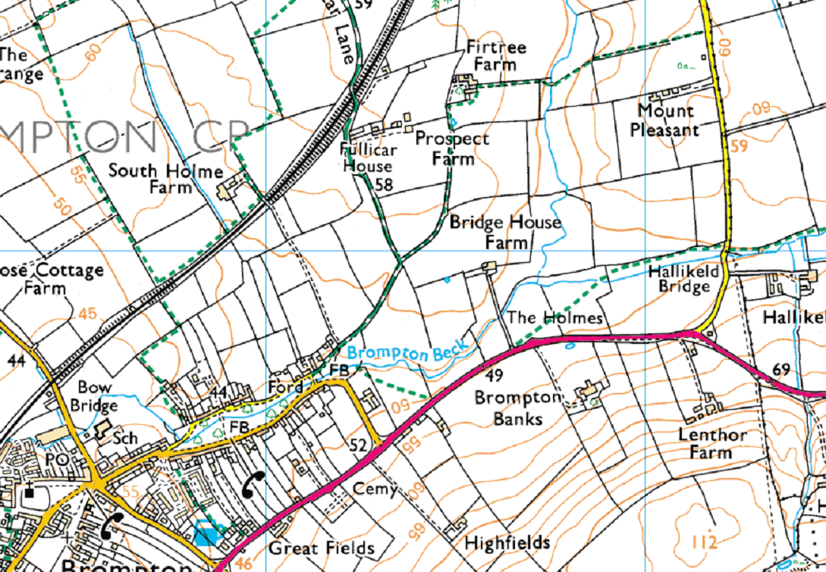
Take Fullicar Lane to the point where it bears left and then follow the track straight ahead towards Firtree Farm. Skirt the farm and follow the footpath to Long Lane. This footpath is interesting, as it descends to a small beck which is easily crossed in dry weather, but may still be slippery and may be dangerous in very wet or icy conditions. Like many of these becks, the hardest part is the scramble down into the gulley and the climb up the other side – which is both steep and slippery.

Turn left and follow the left side of the hedge across the field and on through the gate straight ahead. On Long Lane, turn right - this is a narrow road, so take care and watch out for traffic. The verges are wide, so there is little danger. Follow the road to just before Hallikeld Bridge then turn right onto the footpath through the gateway. This field may be badly rutted and covered in nettles and thistles, but the path is easy to follow – just keep to the right. The stile is in the very far corner, and is probably overgrown. Cross the footbridge and head diagonally across the next field to the stile in the end of the farm drive, just by the main road. On the road, turn right and follow it for about 200 metres.

Here you have a choice. You can cross the stile and follow the footpath round the field to come out by the river, or you can follow the road on round the corner. Drop down to Water End and return to your start.

If doing this walk anticlockwise, watch out for the turning off Long Lane as it is not well marked. Look out for the drive to Mount Pleasant, then a deserted cottage on the left, and go through the next field gate. If you look on the gatepost to your right, there should be a route marker here. Head towards the right side of the hedge which starts in the middle of the field and follow it down to the stream. Turn left along the bank and watch out for the crossing point. The easiest way to find this is to look for the stile and route marker on the far side – the actual crossing is usually overgrown with thistles and nettles.

When you get to Fullicar Lane, you can turn left and return to Brompton (10 minutes) or you can turn right and join the Fullicar Lane to Lowfields walk to give a total route of about 2 hours.

