Sutton Bank - White Horse - Circular
3.7 miles, mainly well trodden paths with some road walking.
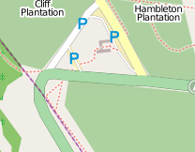
There’s no bus service for this walk from Northallerton except the Moors Bus which runs once a day in summer so you need to drive to the Sutton Bank Visitors Centre and then pay for parking. If you are not bothered about a cup of coffee at the end, you can park at the bottom of the White Horse or off Low Town Bank Road for free and join in the walk at the top of the White Horse.
From the Visitors Centre, head out the back towards the top of Sutton Bank and the main road. Cross with great care, as traffic will not want to stop on the hill and the bend is very sharp. Once across turn left around the top of the scarp on the Cleveland Way. There are tremendous views from here on a clear day, but beware it can be very windy.
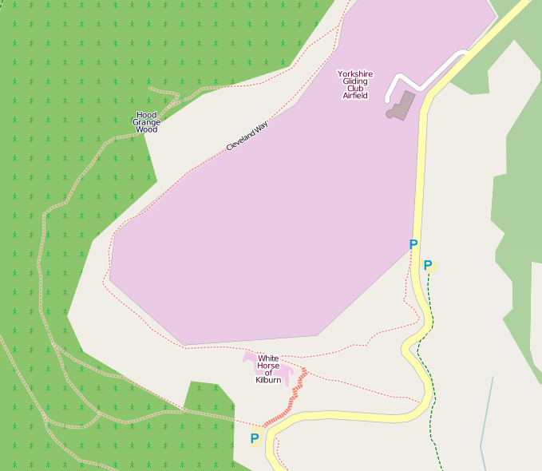
Follow this clear path all the way round the Gliding Club and the top of the White Horse, keeping left all the way until you eventually arrive at the small car park on Low Town Bank Road. Watch out for gliders coming in to land – they can be very low and while there is very little chance of being hit, they can give you quite a surprise.
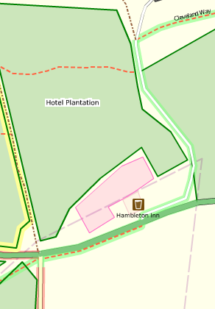
The more agile of you may want to do the low route, marked in red arrows. As you walk round the Gliding Club, admire the views to the west and look out for a path on your right dropping over the side of the scarp. This fairly rocky path cuts down at an angle to meet a forest track which leads round to the car park at the foot of the White Horse. From here you have a choice – either run up the steps or follow the road up to the bend and then cut back on the path to the top of the Horse, where you can admire the views to the South. From here, take the path nearest the Gliding Club to follow round to the road.
If you are avoiding paying for parking, you will be leaving the walk here to collapse into your car, but before you do have a couple of laps of the car park to ‘warm down’ – especially if you have just run up the steps. This gives the leg muscles a chance to relax and will reduce the chances of your legs stiffening up during the drive home.
So, a quick welcome to anybody who has just joined us, and off we go, north, up the road with the Gliding Club on the left. Follow this road round till it joins the A170 and turn right and then, just past the pub, turn left onto the road to Hambleton Hall.
This is part of the Cleveland Way and is well signposted, but just as you reach the edge of the trees, you need to turn left onto the forest path which eventually returns you to the visitors centre.
We hope you enjoy your walk and have no problems following these instructions. If you do encounter any problems, please let us know and we will correct them, and don't forget to add your comments on the walk 4 life site.
http://www.getamap.ordnancesurveyleisure.co.uk/?key=Gqf2U8yECe_tFcbhAmgsYg2

http://www.openstreetmap.org/?lat=54.23991&lon=-1.19957&zoom=16
All maps © OpenStreetMap contributors, CC-BY-SA. See www.openstreetmap.org andwww.creativecommons.org for more information and free maps.
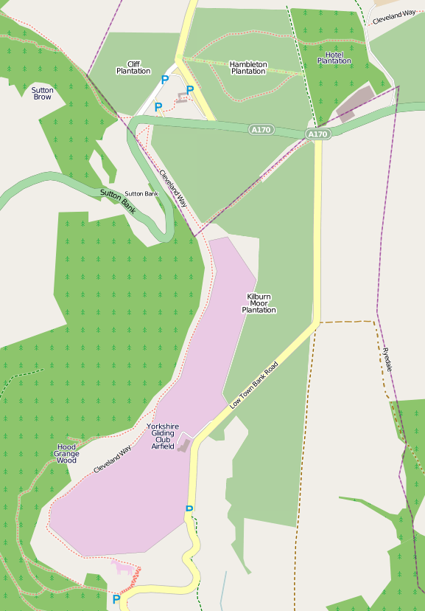
John Brookes
February 2012

