Thornton- le-Moor to Thornton House

This is a very easy route to describe, consisting of a rectangle with the corner bitten off. A bit muddy in places, it’s a route best kept for dryer periods.

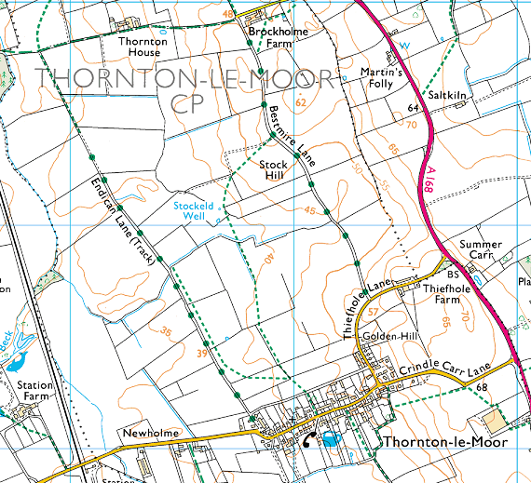
Starting from the pub in Thornton-le-Moor, head down the road to Endican Lane. This starts out life as a modern housing estate (although that gives an exaggerated suggestion of the size – half a dozen houses hardly make an estate), and quickly returns to its roots as a cart track. Fairly straight and fairly level, you hardly notice as it deteriorates into a footpath until it gets so overgrown there is only a winding path through the middle. (Update – as of September 2010, this path has been cleared back so the farmer could get his tractor through.) This changes after about a mile as you pass through a kissing gate into a field, and a few hundred yards further there’s a step-over gate – this is the nearest we get to a stile the whole way round.
Start and finish

At the end of Endican Lane we turn right and head towards Thornton House, which is exactly half way round this walk. Passing over a cattle grid, we enter the working farm roads – watch out for tractors round here. Pass Thornton House and head along to Brockholme Farm.

Turn right just before the farm onto Bestmire Lane, and follow this back towards Thiefhole Lane. This is a working track, so it is not as pleasant a walk as Endican Lane, but by now you will appreciate the extra height to give a bit of breeze and cool you down. There are also some excellent views to the West – and any train spotters will get to see plenty of trains on the East Coast Main Line – although you will need strong binoculars to spot the numbers!

Coming out onto Thiefhole Lane, turn right and follow the road round to the left to return to the village, then a final right turn to get back to the pub for a well earned pint … er … cup of tea!

Risk Assessment
One step-through gate (about 18 inches high)
Narrow, overgrown path in places (possibly)
Nettles and brambles – not excessive
Short length of road walking – medium width, quiet road
No shortcuts,

Can be muddy in wet weather – both Endican and Bestmire Lanes.

Passed the Di test – 1 hour 45 minutes – 5.3 Km

