PEPPER ARDEN, COWTON CASTLE & ST MARY'S

This is a delightful walk up to Pepper Arden to visit St. Mary's church and Cowton Castle, up the Pepper Arden old road. The walk is about three and a half miles long and should take no more than an hour and a half. Take the road in the village towards St. Mary's close, round the back of the church and continue on the old road ahead towards Pepper. You soon pass Temple House farm on your right and the road climbs gently with small woods on the right and views across open country and the stell to the left. In about half a mile you reach the cottage at the top of the hill on your right and should now be able to see Pepper straight ahead. When you reach the crossroads at the foot of the hill turn right and then left to follow the track past the old farm buildings, and on out to the road.
For an easy walk, turn back here and retrace your steps. If you can cope with a couple of stiles (and probably a bit of mud), turn right on the road, and immediately right again through the gate to head diagonally across the field. Find the stiles either side of the drive, and head along the side of the field through two more gates, before turning left to visit St Mary’s Church.
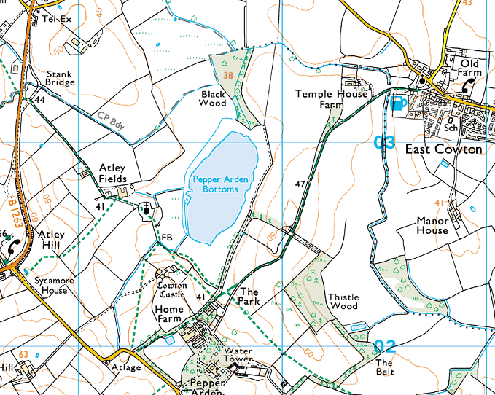
Return on the footpath which runs below the castle hill, either the lower route through the water meadow, or the higher path past the castle. Watch down on the wetlands area for mallard, waterhen and heron. Enjoy the peacefulness of the location and then retrace your steps to East Cowton for a well earned drink at the Beeswing.

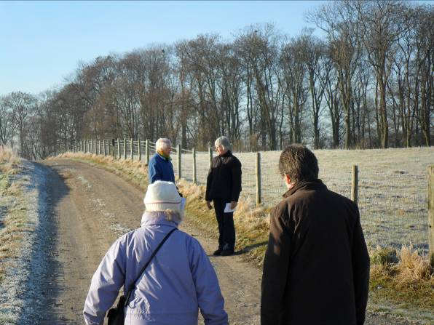
The basic walk from East Cowton to Home Farm and back is entirely along a hard-core farm track, apart from approximately 20 m across grass. The grass section is slightly uneven underfoot, but poses no significant risk. There are sections of the track which may be muddy in wet weather, but there are no specific risks.
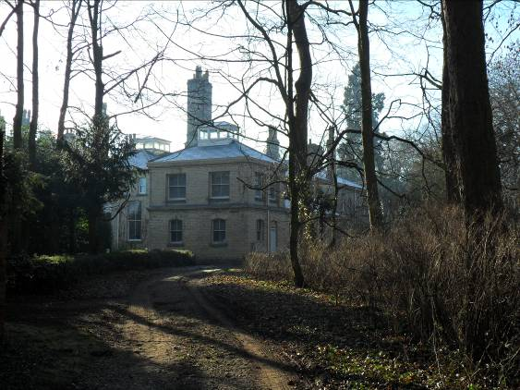
Pepper Arden Hall and the impressive water tower are on private land and should not be visited without specific permission from the landowners.

There are three other risk-assessed extensions to this walk. Any of these can be reversed to provide variety.
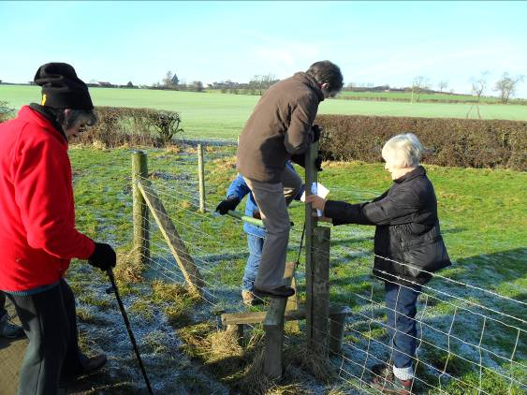
- Immediately on reaching the road, turn right, go through the gate and head diagonally across the field, over two stiles and around the corner of the next field to return beside Pepper Arden Bottoms (choice of 2 paths, one has a stile). Beside the stiles, this route can be muddy going through the gates and the lower path can be wet.
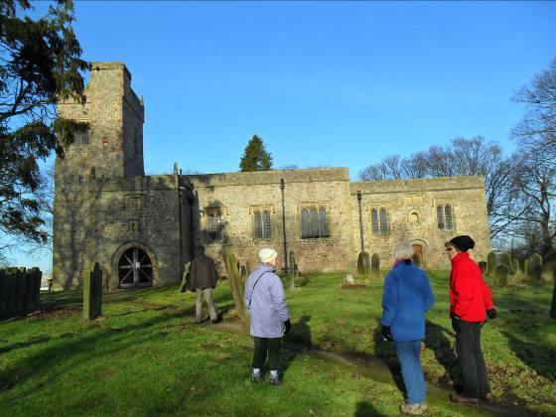
- From the corner of the field in the last paragraph, you can go through the gate and visit the church before returning via the same route. The gate can be very muddy, but otherwise there are no hazards.
Note – it is not clear from the map, on return from the church you must go back through the gate – the path is on the South-West side of the hedge.
- On reaching the road, you can turn right and follow the road for approximately 400 m before turning right over the stile (or through the gate if it is open) and across the field to arrive at the church. When last visited, this field have been ploughed and was sticky, but by now it should have been cleared. If it is intended to use this route, it should be assessed separately at the time.

